**Rate monotonic scheduling** is a priority algorithm that belongs to the static priority scheduling category of [Real Time Operating Systems](https://www.geeksforgeeks.org/real-time-operating-system-rtos/). It is preemptive in nature. The priority is decided according to the cycle time of the processes that are involved. If the process has a small job duration, then it has the highest priority. Thus if a process with highest priority starts execution, it will preempt the other running processes. The priority of a process is inversely proportional to the period it will run for.

A set of processes can be scheduled only if they satisfy the following equation :

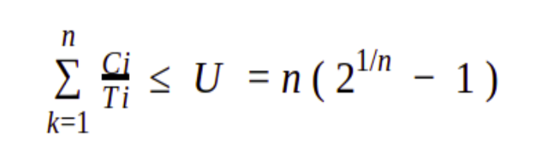

Where n is the number of processes in the process set, Ci is the computation time of the process, Ti is the Time period for the process to run and U is the processor utilization.

**Example:**  
An example to understand the working of Rate monotonic scheduling algorithm.

| Processes | Execution Time (C) | Time period (T) |
| --- | --- | --- |
| P1 | 3 | 20 |
| P2 | 2 | 5 |
| P3 | 2 | 10 |

n( 2^1/n - 1 ) = 3 ( 2^1/3 - 1 ) = 0.7977

U = 3/20 + 2/5 + 2/10 = 0.75

It is less than 1 or 100% utilization. The combined utilization of three processes is less than the threshold of these processes that means the above set of processes are schedulable and thus satisfies the above equation of the algorithm.

1. **Scheduling time –**  
   For calculating the Scheduling time of algorithm we have to take the LCM of the Time period of all the processes. LCM ( 20, 5, 10 ) of the above example is 20. Thus we can schedule it by 20 time units.
2. **Priority –**  
   As discussed above, the priority will be the highest for the process which has the least running time period. Thus P2 will have the highest priority, after that P3 and lastly P1.

P2 > P3 > P1